## Electroshock Base

# User Guide

### By: Abhishek Madan and Jeffrey Ying

Overview

The menu bar, located at the top of the window, is split into 3 headings: *File*, *Edit*, and *Help*. The *File* heading contains a Save command and an Exit command; the *Edit* heading contains an Add Employee command and a Search command; and the *Help* heading contains a Help command and the About command. All usage of the database is centred around this menu, as well as the search bar. To run the program in NetBeans, save the folder called “Employee Database” (which includes this file) into the folder where NetBeans projects are stored, then right-click the project called “Employee Database” in the top-right corner of the screen, and select the Run option.

Add Employee

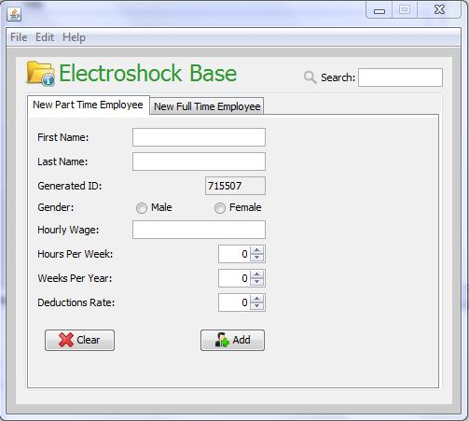When this option is selected, the database will display the following form:

The Add Employee screen for a part time employee.

There are two separate forms: one for creating a new part time employee, and one for creating a new full time employee, each of which can be accessed through the tabs called “New Part Time Employee” and “New Full Time Employee”. The screenshot above displays the form that must be filled out for creating a new part time employee.

By hovering the mouse over certain fields, it will give instructions on what kind of information must be entered into them. For example, the Deductions Rate field must be a percentage value between 0 and 100. Any of the arrow buttons beside field boxes can be used to adjust the numerical value of the fields they are attached to, or a value following the specifications can be typed into the box directly. **Note: the Generated ID (the employee number) is randomly generated; it cannot be changed.** If the Add button is clicked and there are any errors in the form, or some fields are not filled out, they will be displayed beside the field box which sent the error. These fields must be fixed to have appropriated data, after which a message will be displayed that the employee was successfully added. To clear out all the fields at once, press the Clear button.

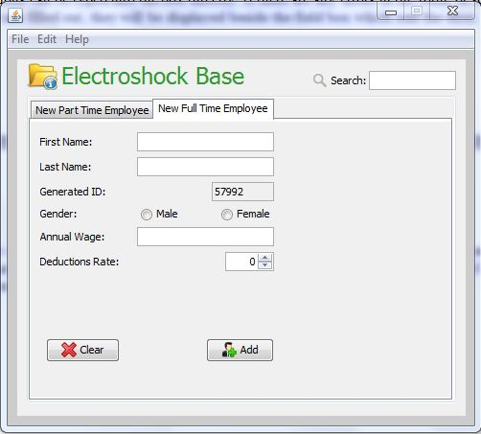The Add Full Time Employee form, displayed below, is filled out in the same manner, except that the Hourly Wage, Hours Per Week, and Weeks Per Year fields are replaced by a single Annual Salary Field.

The Add Employee screen for a full time employee.

#### Search

This option in the menu bar is just a redirect to the search bar in the top right corner of the screen. Type in an employee number into the system, and the database will display information for the employee with a matching employee number. **The search bar only handles search by employee number; any other form of searching is not supported.** The database will display a message if the employee was not found; otherwise, it will display the information in the format shown in the screenshot on the next page.

Any of the field boxes can be edited (except for Generated ID) with the same specifications as are required when creating an employee. To modify the employee with the changes, press the Update button.

Viewing an employee also displays their gross annual pay (before deductions) and their net annual pay (after deductions) at the bottom of the window. These cannot be edited directly, since they are calculations made by employee data.

An employee can also be deleted from the database by pressing the Delete button. They cannot be restored unless their information is entered in as a new employee, but their employee number will be different. This screenshot shows information displayed for a full time employee:

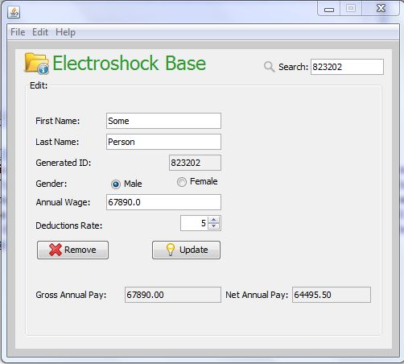

The Edit Employee screen for a full time employee.

##### Save

When this option is selected, the employee information on the database is backed up to a file called “employees.txt”. Do NOT delete this file, or the database will not load when it is started up.

###### Exit

This option is an alternative to clicking the close button in the top right corner of the window. If either this Exit option or the close button is selected, the database automatically backs up.

Help

This option displays a text-only version of this guide, for quick reference while using the database. Do not delete the file called “help.txt”, or the Help feature will not load.

About

This option displays a brief background on the creation of this database.